**TITLE OF PROJECT**



**END TERM REPORT**

***By:***

**Names of Candidates:**

**Rahul kadam**

**Arun Kumar**

Section: K19QK

Roll Numbers: 16, 22

**Department of Intelligent Systems,**

**School of Computer Science Engineering,**

**Lovely Professional University, Jalandhar**

November, 2020

**ACKNOWLEDGEMENT**

In preparation of our assignment, we took the help and guidance of some respected persons, who deserved our greatest gratitude. As the completion of this assignment of this assignment gave us much pleasure, we would like to show our gratitude Mr. Dhanpratap Singh, Course Instructor, on LOVELY PROFESSIONAL UNIVERSITY for giving us a good guideline for assignment throughout numerous consultations. In addition, a thank you to Professor Dhanpratap Singh, who introduced me to the Methodology of work and whose passion for the underlying structures had lasting effects.

**Student Declaration**

This is to declare that this report has been written by us. No part of the report is copied from other sources. All information included from other sources have been duly acknowledged. We aver that if any part of the report is found to be copied, we are shall take full responsibility for it.

Name: Rahul kadam

Arun Kumar

Roll Number: 16, 22

Date: 30/10/2020

**TABLE OF CONTENTS**

**TITLE PAGENO.**

|  |  |
| --- | --- |
| 1. **Description of Project 1** 2. **Pictorial View 2** 3. **Working division along group members 3** 4. **Technologies and frame work used 4** 5. **Background and objectives of project assigned 5** |  |

**DESCRIPTION**

Calculator:

A Calculator is a software application used to make our calculations easy and fast. Every day we use it, we all know how much it helps to do our calculations quickly.

How does it actually works?

We created a function for every activity which it performs, we take the values from the user, then user tells the software to which operation he would like to perform, then we perform the operation, and then it gives us the result.

we made this project (Calculator) with use of Python programming language.

This project is GUI based program, where we used tkinter module, functions and other parts.

As we are not using any hardware

1. So first user will give the input like first number of the calculations.

2. Now user tells the software what operation he wants to perform.

3. And then user enters the second number, and when he hits enter button then calculator shows the result.

**PICTORIAL VIEW**

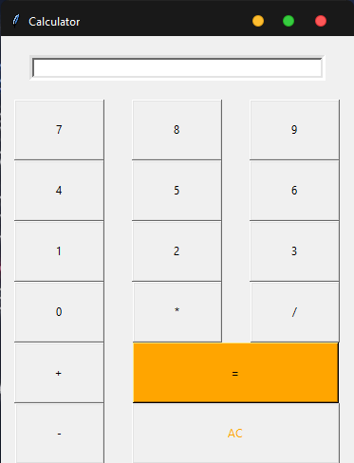

**WORK DIVISION AMONG GROUP MEMBERS**

**Work done by Rahul Kadam:**

Most of the programming part of the project is done by Rahul Kadam. Used Python programming for the project, including Tkinter for GUI based project.

**Work done by Arun Kumar:**

Report writing part is been done by Arun Kumar. Using MS-WORD for the project.

**TECHNOLOGIES AND FRAME WORK USED**

**Programming Language:**

Python Programming: Python is an interpreted, high-level and general-purpose programming language. Created by Guido van Rossum and first released in 1991, Python's design philosophy emphasizes code readability with its notable use of significant whitespace. Its language constructs and object-oriented approach aim to help programmers write clear, logical code for small and large-scale projects

**IDE Used:**

Visual Studio Code: Visual Studio Code is a free source-code editor made by Microsoft for Windows, Linux and macOS. Features include support for debugging, syntax highlighting, intelligent code completion, snippets, code refactoring, and embedded Git. Users can change the theme, keyboard shortcuts, preferences, and install extensions that add additional functionality.

**For GUI:**

Tkinter: Tkinter is a Python binding to the Tk GUI toolkit. It is the standard Python interface to the Tk GUI toolkit, and is Python's de facto standard GUI.Tkinter is included with standard Linux, Microsoft Windows and Mac OS X installs of Python.

## **Background of Calculator:**

## **What Is Calculator?**

Calculator is a software used to help you during the calculation, it is very easy to use, we can perform multiple operations using the calculator, like addition, substrction, multiplication, and division.

**What You Need to use calculator?**

When it comes to calculation, if we have lot of data to calculator, so we can’t do it on our own. There calculator comes in use. It can help us to perform complex calculation, and also it’s not hard to use.

**Objective of calculator:**

Every day we need to perform various calculations, or when we are solving math’s problems, we can’t do complex calculation or problems on our own, some where along the way we will mess up with the values, at there calculator comes in place, we can perform all types of calculation and we can solve every problem using the calculator.